**WEEK-1**

1. List all the files and directories of ‘/bin’ with detail information from your current directory.

**Command:** ls

**Screenshot**:

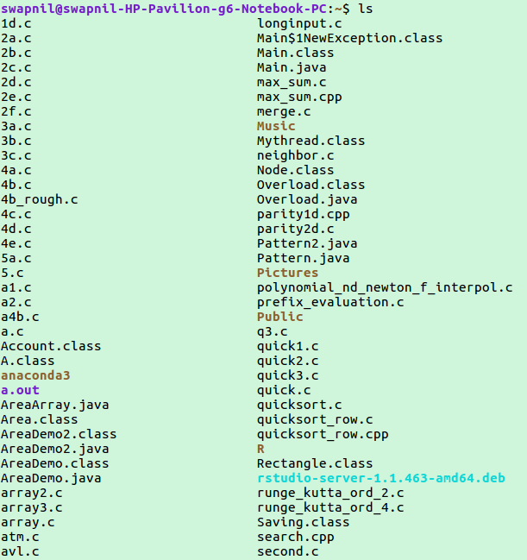

2. List all the files including hidden files in your parent directory.

**Command:** ls -a

**Screenshot**:

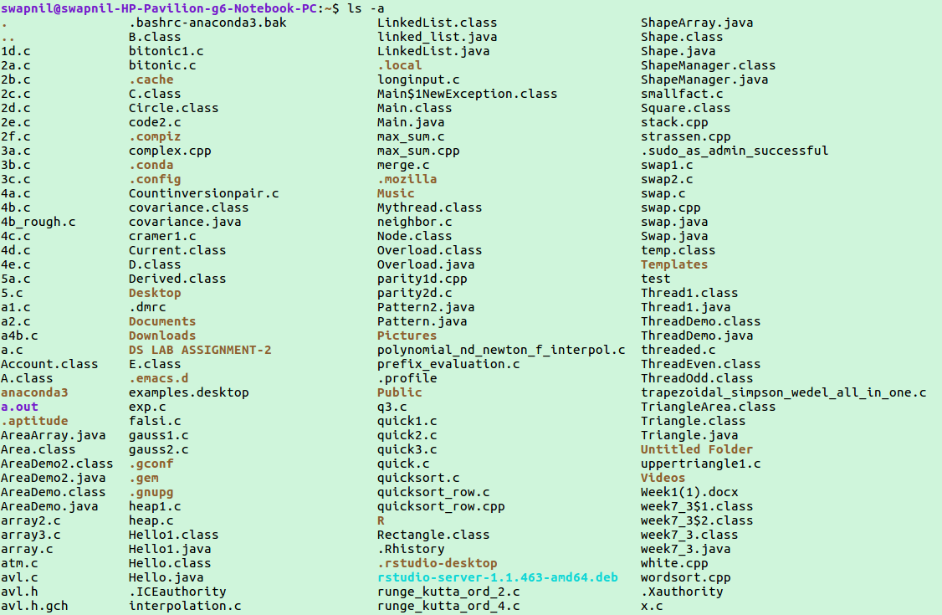

3. List only the directory files in your current directory.

**Command:** ls –d \*/

**Screenshot**:



4. Create a file ‘text 1’ by taking input from the keyboard.

**Command:** touch text1.txt

nano text1.txt

**Screenshot**:

C:\Users\USER\Desktop\OS\os sc\os_q4_1.png

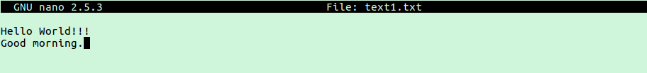

5. Copy the contents of file’ text1’ to another file ‘text2’.

**Command:** cp text1.txt text2.txt

nano text2.txt

**Screenshot**:

C:\Users\USER\Desktop\OS\os sc\os_q5_1.png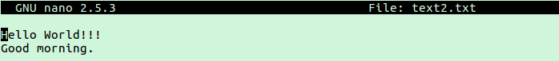

6. Append the contents of file ‘text2 ‘to file ‘text1’.

**Command:** cat text2.txt >> text1.txt

nano text1.txt

**Screenshot**:

C:\Users\USER\Desktop\OS\os sc\os_q4_1.png



C:\Users\USER\Desktop\OS\os sc\os_q6_7.png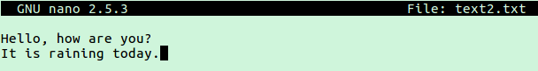C:\Users\USER\Desktop\OS\os sc\os_q6_3.png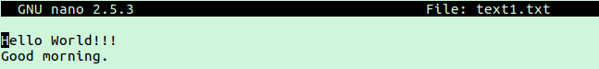C:\Users\USER\Desktop\OS\os sc\os_q6_1.png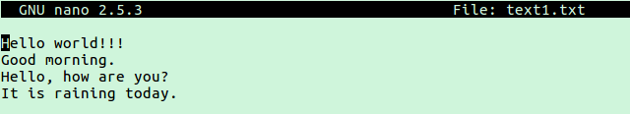

7. Count the number of lines in the file ‘text1’.

**Command:** wc -l text1.txt

**Screenshot**:

C:\Users\USER\Desktop\OS\os sc\os_q7.png